Binarisations 2003 vol 2 digital prints

"Bernard Demiaux is an artist who has used Internet technology since its inception in his works of art. He is the creator of several original works of art using a special technique with computers.
He has created the "Binarisations" series, a set of informational objects that are composed of a succession of zero and one bits (0/1) that are presented in the form of digital pictures and animated mural sculptures. His latest works focus on the digital portraits of Mexican Shamans where he uses the binary (O/1) effects to highlight and then reinforce the magical and supernatural feeling of these encounters.
Bernard also manipulates the "fog" and "shade" elements of his digital representations which he captures through particles of light in suspension emphasizing energy that is invisible to the naked eye.
The combined effects of binary signs and saturation constitute a new way to suggest the "other side".
He has captured "moments of emotion" from his frequent trips (voyages) to the United States and Latin America, which today, he transforms into his series of engraved works and digital prints that he calls, "Binarisations. "

Norbert Hillaire Paris 2003 – Art critic

digital prints

technique : digital print
size in inches : 23,6 x 31,5
edition size : 64 copies from 1 to 64, 4 artist proof from EA1 to EA4, 4 HC from HC1 to HC4, on premium paper 215g
printer : digital art – Paris

monotypes and large sizes on order

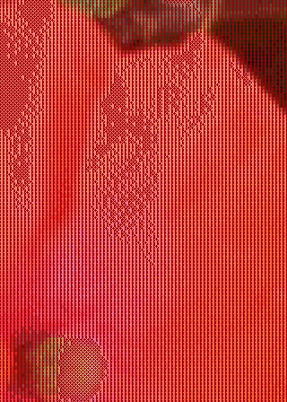 | 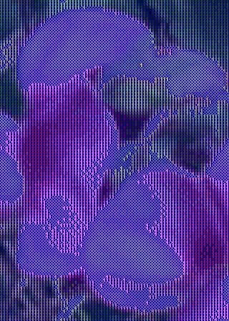
Flowers #1 - 2003 | Flowers #2 - 2003
Digital print - ref 2003_15 - 64 copies | Digital print - ref 2003_16 - 64 copies
600x800 mm – 23,6x31,5 inches on premium paper 215g | 600x800 mm – 23,6x31,5 inches on premium paper 215g

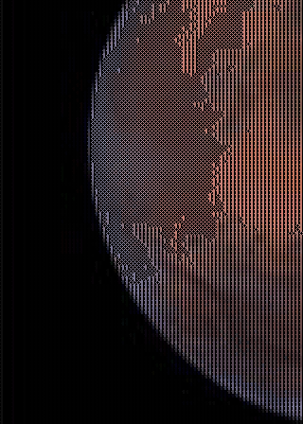 | 
Soleil de Mars #1 - 2003 | Cross border #1 - 2003
Digital print - ref 2003_17 - 64 copies | Digital print - ref 2003_18 - 64 copies
600x800 mm – 23,6x31,5 inches on premium paper 215g | 600x800 mm – 23,6x31,5 inches on premium paper 215g

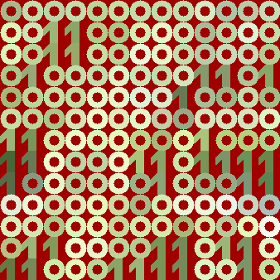 | 

samples - real size

 | 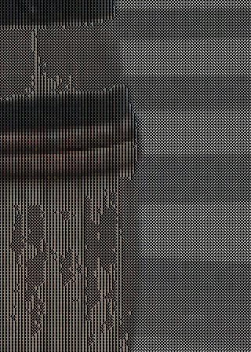
Reflet #1 - 2003 | Tonneau royal #1 – 2003
Digital print - ref 2003_19 - 64 copies | Digital print - ref 2003_20 - 64 copies
600x800 mm – 23,6x31,5 inches on premium paper 215g | 600x800 mm – 23,6x31,5 inches on premium paper 215g

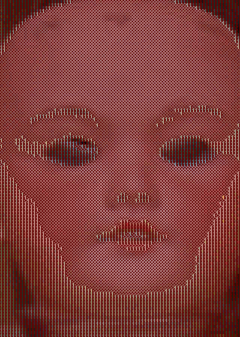 | 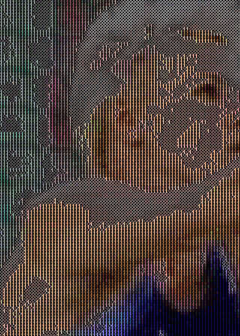
Dolly & co #1 - 2003 | Dolly & co # 2 - 2003
Digital print - ref 2003_21 - 64 copies | Digital print - ref 2003_22 - 64 copies
600x800 mm – 23,6x31,5 inches on premium paper 215g | 600x800 mm – 23,6x31,5 inches on premium paper 215g

 | 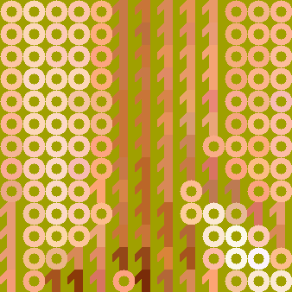

samples - real size

 | 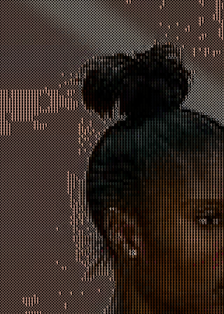
Virtual skin #1 - 2003 | Black Power #2 – 2003
Digital print - ref 2003_23 - 64 copies | Digital print - ref 2003_24 - 64 copies
600x800 mm – 23,6x31,5 inches on premium paper 215g | 600x800 mm – 23,6x31,5 inches on premium paper 215g

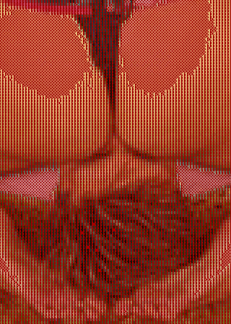 | 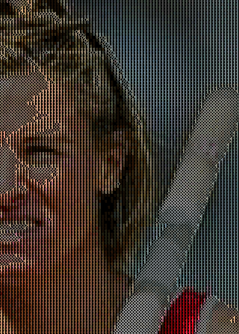
Face 2 face #1 - 2003 | Face 2 face #2 - 2003
Digital print - ref 2003_25 - 64 copies | Digital print - ref 2003_26 - 64 copies
600x800 mm – 23,6x31,5 inches on premium paper 215g | 600x800 mm – 23,6x31,5 inches on premium paper 215g

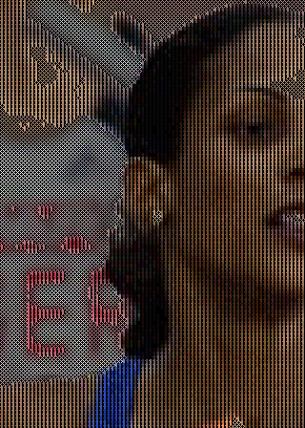 | 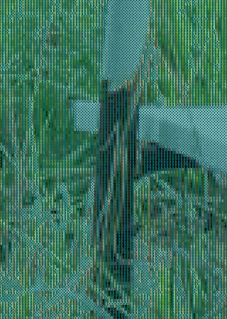
Gold side # 1 - 2003 | Rusty grass # 1 - 2003
Digital print - ref 2003_27 - 64 copies | Digital print - ref 2003_28 - 64 copies
600x800 mm – 23,6x31,5 inches on premium paper 215g | 600x800 mm – 23,6x31,5 inches on premium paper 215g

Artist, expert in digital art, he lives and works in Paris and Berkeley.
Prize winner of the “Médicis Villa out the Walls” in 1996 and Grand Prize of the Biennial of Graphic art of Seoul in 1990, he is one of the pioneers of numerical art in France.
He has been creating digital works for more than 25 years and he exposed in many large international Museums: George Pompidou Center, Museum of Sciences of the Villette, Documenta Kassel, Biennale of Venice, Museum of Modern Art of Bologna, Museum of Contemporary Art of Sao Paulo.
He co-authord "Objects Plus" with Pierre Restany (1989) and is the author of the Informational Manifesto (1992).
It founded the Digital Art group in 1979. The first emblematic demonstration of the group was at the Grand Palais in Paris 1980 and it introduced American, Canadian, Belgian, Swedish and French artists painting, sculpting and composing electronic music with the help of computers.
He founded the Center of Binarisation in 1990 to promote artistic performances on the Internet. These performances call upon public participation. They produce co-operative works. These works play with the imaginary emerging from the network and allow a questioning of the role of the artist, the statute ofhis work, shared creation and the nature of the artistic object: reality or virtual.
Bernard Demiaux launched several Internet multi-media start-up. He brought back from his frequent voyages in the United States and Latin America "moments of emotion" which he fixes today in his engraved works.

